**“Evocator: College Admission Predictor”**

**1MRS. KANCHAN A. KHEDIKAR**

**Assistant Professor, Computer Science & Engineering Department,**

Walchand Institute of Technology, Solapur, India. Ashok Chowk, P.B.No.634, Solapur- 413006

**1 PRIYANKA DANDI, 2 RITIKA KURAPATI,3 PRATHAMESH MANAKAPURE,**

**4 ANEKANT MADRAP, 5 SANDEEP GONE**

**Student, Computer Science & Engineering Department,**

Walchand Institute of Technology, Solapur, India

Ashok Chowk, P.B.No.634, Solapur- 413006

Email: [kakhedikar@witsolapur.org](mailto:kakhedikar@witsolapur.org), [priyanka.dandip@gmail.com](mailto:priyanka.dandip@gmail.com), [ritika.kurapati@gmail.com](mailto:ritika.kurapati@gmail.com), [anekant.madrap07@gmail.com,sandeepgone2001@gmail.com](mailto:anekant.madrap07@gmail.com,sandeepgone2001@gmail.com)

Contact: 7773982360, 9096892655, 9284905129, 8605558560, 9284061181, 8788398294

**Abstract:** Web-based application system known as College Admission Predictor System where students can enroll their marks along with their personal information. This helps student to predict their admissions in colleges. It helps students to make correct decisions for choosing their college. In which students can register with their details as well as marks details for prediction of admission in colleges. Sometimes the students are probing the admission to the college for she or he are not eligible as per the merit of that college. So here we built predictive model to guide the students about their admissibility in the desired college & also suggest the college where they will get the admission. So, to achieve this objective we may include machine learning capacity that increase performance based on experience, just as humans do. A machine learning model is built in order to provide results. The dataset contains historical AP-CET cutoff percentile of various universities with branches. Various algorithms have been used to train the model for given dataset and predict results. Algorithms used are Random Forest, Decision Tree Classifier. The model analyzes student academic merits, category and college admission criteria. Based on that, it predicts the best of a university college that a student may enter.

Basically, our system focuses on developing an efficient and user-friendly web application.

***Index terms: college predictor, AP-cet, machine learning, Decision Tree algorithm, cet mark.***

**______________________________________________________________________________________**

1. **INTRODUCTION**

After HSC examination, utmost of the students chooses engineering to make their career. For engineering admission, students have to give CET entrance test, which plays vital part in admission process. During admission process, Students have to give their preferable college list. Numerous of students make mistake while listing colleges due to various reasons like inaccurate analysis of college, lack of knowledge, improper guidance, increase in competition etc. This leads to several issues like a pupil may not get dream college, distributed a college which isn't affordable, college may have no core placements or few placements which makes student to struggle more to get placed in industry. The main objective of College Admission Prediction system is to make better choices of college before allotment. It can handle the details of students such as merit details. This student Database has been designed that holds first name, last name, username, password, branch, category. In Andhra Pradesh, admissions for engineering is grounded upon common entrance test( CET) and since further than lakh seats are to be assigned in further than 200+ engineering colleges and 35 different branches of engineering, for students belonging to categories like open, home university, outside home university, reserved order( SC, ST, OBC etc.) the problem becomes more serious and students struggle to understand which college they're likely to get admitted in, indeed after going through cut- off data of former times. Many students fill wrong options and fail to get admission. To minimize the stress of scholars we propose the idea of a computer based system which will help students to get the list of all colleges in which they could get the distributed at the click of a button.

# LITERATURE REVIEW

1. **Predictive Analytics Models for Student Admission and Enrollment:**

In this paper, they have developed analytical model for a local university based on historical built on neural networks, decision trees and logistic regression. However, this model cannot be self-determined and only assists to compliment university administrators' decision-making process to manage admissions and enrolment.

1. **An Automated Prediction Model for College Admission System:**

In this paper, they have done the necessary research using K-CET (Karnataka Common Entrance Test) data. Our system is developed taking K-CET into consideration. Use data analytic techniques to prepare a preference list based on the user’s input. The preference list varies depending on user input.

1. **Prediction for University Admission using Machine Learning:**

In this paper, they created a Machine Learning model which could be used by students who want to pursue their education in the US, they considered only few universities with different rankings.

# Hybrid Recommender System for Predicting College Admission:

# In this paper, this system consists of two cascade hybrid recommenders working together with the help of college predictor. Students it uses previous students’ admission data of colleges GPA for predicting most probable colleges. It looks over student academic merits, background, student records, and the college admission criteria. Then, predicts the possibility of university colleges that a student may enter. The design is proposed only of Saudi Arabian Universities.

1. **CAPSLG**:

College Admission Predictor and Smart List Generator In this paper, the Ensemble AdaBoost Classifier from the scikit-learn library of Python is used for classification of the data. The model is trained for the individual colleges under the Mumbai region. The project includes application of machine learning algorithm on the data-set of cut-off lists of colleges for past 3 years.

1. **SYSTEM ARCHITECHTURE**

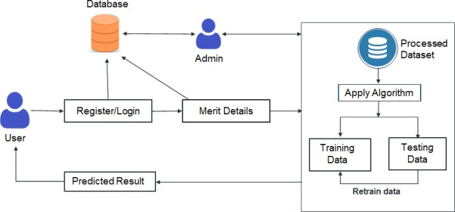

**Figure 1. System Architecture**

Main tools used are Django and Machine Learning to develop college admission predictor. Django is opensource python web framework used to develop User interface of website. Initially user has to register and login with valid credentials. For registration user’s First name, Last name, City, Email Id and password are required fields, these details are stored in database and fetched from database while login. User have to give valid details in case of invalid details Error message is given to give valid credentials. For database management PostgreSQL is used. PostgreSQL is the primary data store or data warehouse for many web, mobile, geospatial, and analytics applications. PostgreSQL is an 10 advanced, enterprise-class, and open-source relational database system and supports both SQL (relational) querying. After login, Merit and other details required for prediction are provided. Merit details include HSC percentage, CET percentage, Math marks and whether user is of PCM (Physics, Chemistry, Math) or PCMB (Physics, Chemistry, Math, Biology) stream. If a student has HSC percentage less than 50% (less than 45% for reserved/ backward category/ Persons with Disability)) then student will not be eligible for Engineering hence in that case proper message is shown.

1. **TECHNOLOGY USED**
2. **HTML (Hyper Text Markup Language):** Hyper Text Markup Language is the standard markup language, used for creating Web application and describing the structure of our Web application. It consists of a series of elements, which tell the browser how to display the content. HTML code ensures the proper formatting of text and images for our Internet browser. It is use to develop static web page for

designed our project

1. **CSS (Cascading Stylesheet):** Cascading Style sheet is the language for describing the presentation of our Web application including colors, layout, and fonts. It agrees one to adapt the presentation to different types of devices, such as large screens, small screens. CSS offers several significant advantages over alternative approaches to web design. It is use to describe the presentation of document written in html for our project
2. **Python:** Python is open source, interpreted, high level language and provides great approach for object-oriented programming and widely used by data scientist for various data science application. It gives great functionality to deal with mathematics, statistics and scientific function. For implementing machine learning model python has been used. It is use for implementation of machine algorithm.
3. **JavaScript:** JavaScript is a light weight object-oriented programming language and is one of the core technologies. Developers can use JavaScript to get data from other sources and display it on their own site. We used java script to create interactive web content and for scripting our web pages. It is use to develop interactive web page for our project.
4. **Django:** Django is a high-level Python web framework that authorize rapid development of secure and maintainable websites. Django follows MVT (Model View Template) architecture. It is used for developing clean web application. For Simplicity and Scalability Django is used develop web application. It is use to develop secure web page and connected to database for our project.
5. **PostgreSQL:** PostgreSQL is a free and open-source relational database management system. It is used as the primary data store for many webs, mobile applications. It has the richest set of features that are supported by Django. It is faster when dealing with massive datasets, complicated queries, and read-write operations. PostgreSQL is used to deal with user data. It is used to store data from user in project.
6. **Machine Learning Algorithms:** Machine learning algorithms can be applied on dataset for cost savings, improved time, and performance. machine learning techniques can handle large and complex data to draw interesting patterns or trends in them such as anomalies. Machines are required to process information fast and make decisions when it reaches the threshold. There are many machine learning algorithms that help to do better data analysis. We used two different types of algorithms. It is used to predict accurate result.

# METHODOLOGY

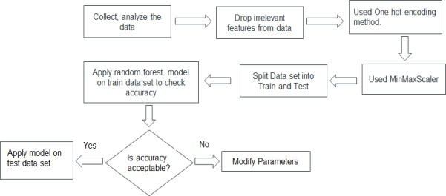

**Decision Tree:** A decision tree is non-parametric supervised learning. It is used for both classification as well as regression problems. It is a flowchart-like structure where each internal node represents a “test” on an attribute, each branch represents the outcome of the test, and each leaf node represents a class label. The path linking root and leaf represents classification rules.

**Random Forest:** Random Forest builds decision trees on different samples and takes their majority vote for classification and average in case of regression. It is group learning method for classification, regression and other tasks that operates by constructing a multitude of decision trees at training time. For classification tasks, the output of the random forest is the class selected by most trees. It provides productive way of handling missing data. It can build a reasonable prediction without hyper-parameter tuning. It helps to solve the problem of overfitting in decision trees. In every random forest tree, a subset of characteristics is selected randomly at the node’s splitting point.

**About the Dataset:** To achieve all the objectives we need past admission data of multiple Engineering colleges to work on. So, we have collected various University’s engineering colleges admission record. As we are focusing on AP-CET so we collected only the colleges of Andhra Pradesh state. This Dataset has various attributes, which are: rank, gender, caste, region, branch, fee.

**Data pre-processing:** It is an important task in machine learning. It converts raw data into clean data. Missing Value are those values that crashed to load information or the data itself was corrupted. There are many techniques to handle missing values. One of which we have used is deleting rows because some of the rows were blank. Handling Categorical Data (One Hot Encoder) – This is one of the most frequently used techniques for the categorical variable. Label encoder turns labels into a numeric format so that the machine can recognize it. In our data, there are four categorical columns like Gender, Branch, Region, Caste.

**Model Implementation:** After cleaning all the data, removing all the noise, selecting relevant features and encoded it into machine learning form, the next step is building a predictive model by applying various ML techniques to search out the best model which gives us more accuracy for train and test both. But before that, we must divide our data into 2 parts.

**Train-Test Split**: The training data set is used to create the model while testing the data set is used to check the performance. Training data’s output is accessible to model while test data is unseen data. So, in our data, we have split data into 85% for training data and 15% for testing data because it makes the classification model better.

**Comparison of Result (Actual Vs Fitted):** We have used 2 standard algorithms for prediction of college which includes Decision Tree, Random Forest. The chosen appropriate algorithms run through test harness of number of splits 15 and performance major accuracy.

After observing accuracy results of the model, we can simply understand the accuracy of classifier Decision Tree is seen more practical. After finalizing classifier of the model sometimes we required tuning the model for better accuracy. Tuning is the method for increasing a model's performance without over fitting the data or making the variance too high. We have taken single record to classify the college & tested. For this single record we have again build 2 predictive model and tested for different input variable. So, we found every time

that Decision Tree always give great accuracy than other algorithms.

# VI. Comparison of Various Algorithm

|  |  |  |
| --- | --- | --- |
| **Algorithm** | **Testing Accuracy** | **Training Accuracy** |
| Decision Tree | 0.6989 | 0.9987 |
| Random Forest | 0.6240 | 0.9802 |
| Native Bayes | 0.5948 | 0.6048 |
| Logistic Regression | 0.0386 | 0.0371 |
| K Neighbors classifier | 0.5030 | 0.6610 |

# 

The accuracy for the Decision Tree Algorithm is more than the other algorithms, so we choose the Decision Tree Algorithm.

## VII. TOOL SNAPSHOTS

We have made a tool where users can search for any type of file by providing a keyword and file which are having keywords are shown on the output console.

The developed Searching Tool is:



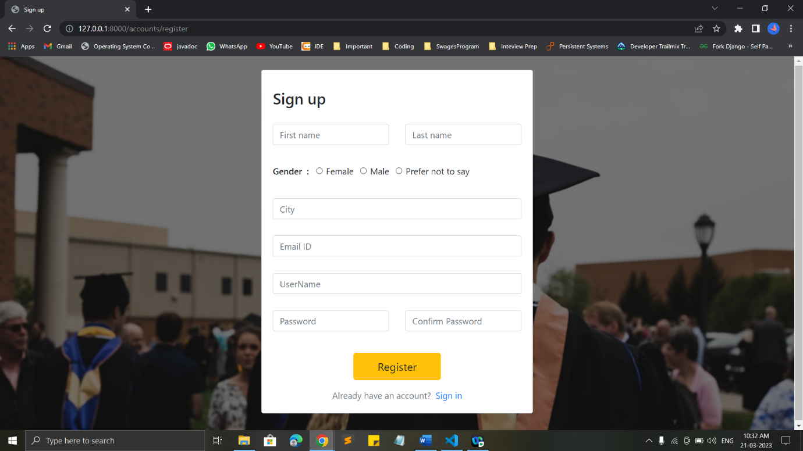

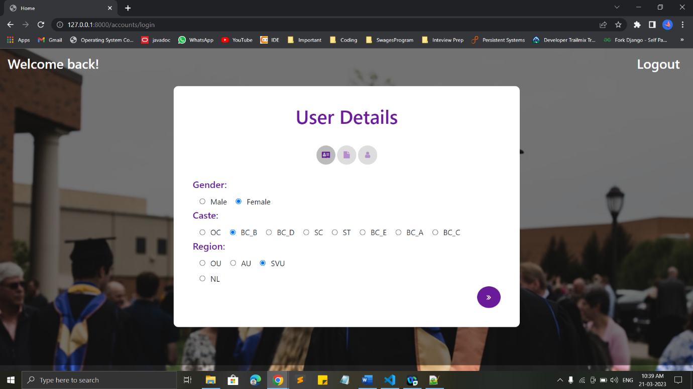

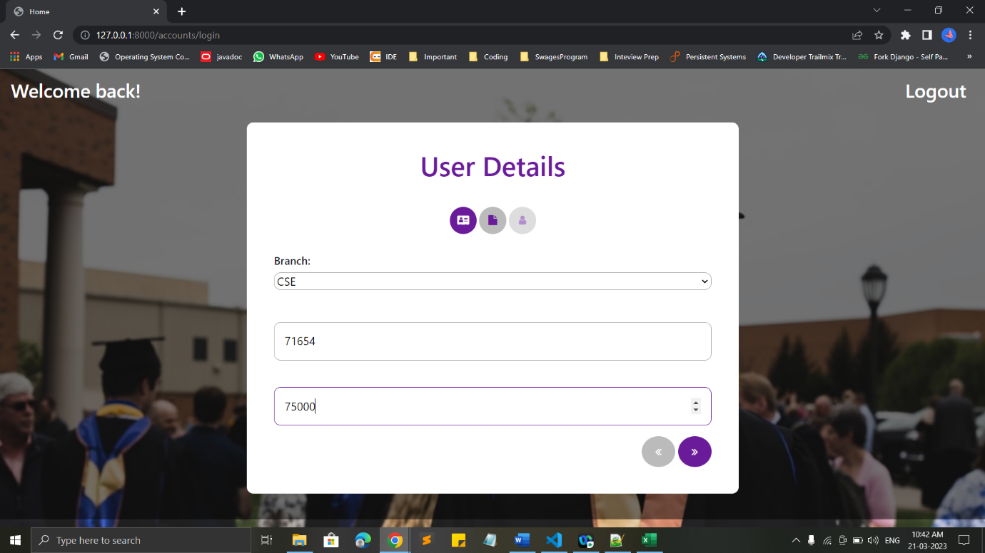

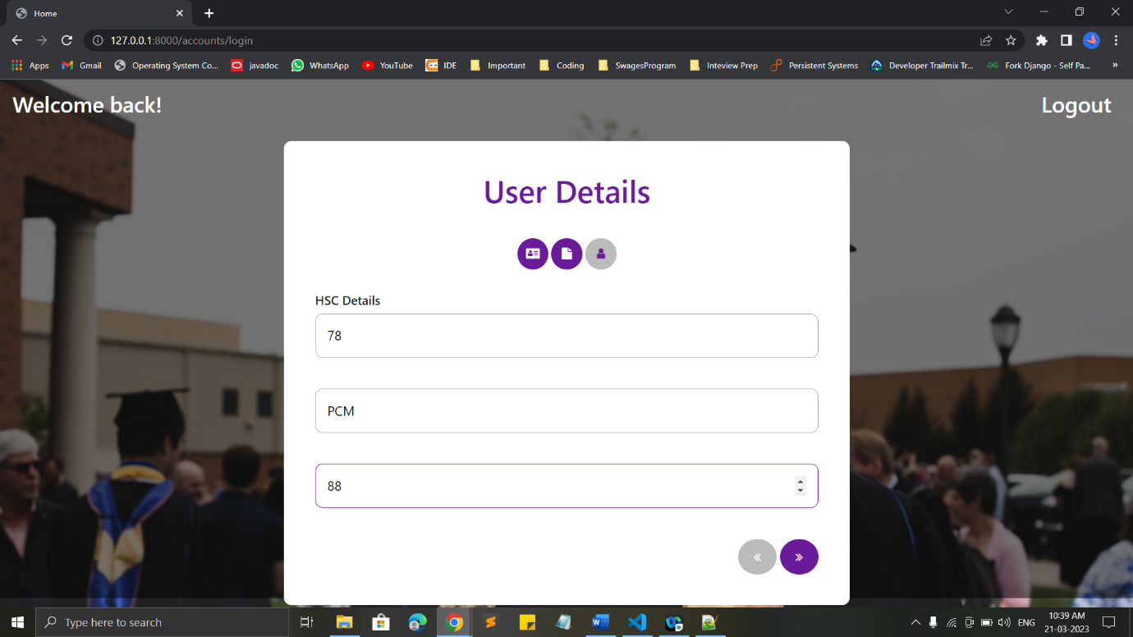

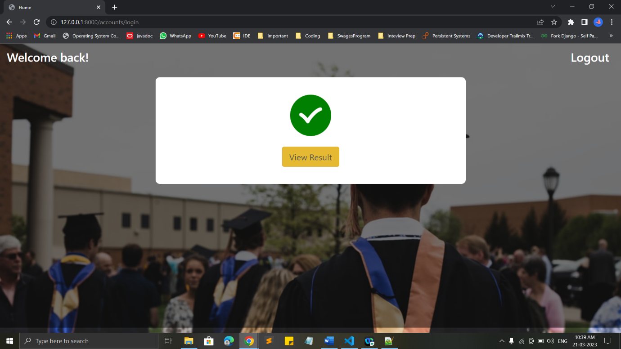

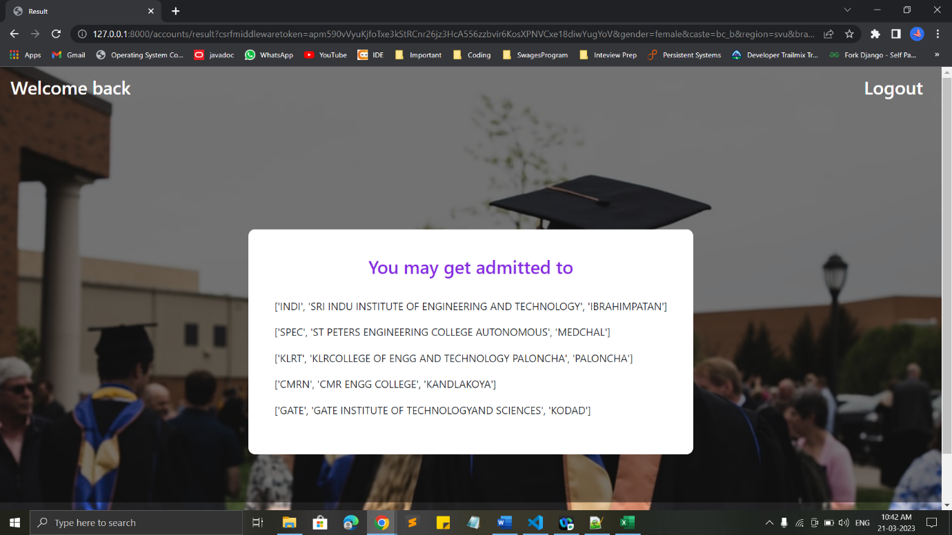

**VIII. CONCLUSION**

We have efficiently processed and implement the college predictor for the prediction of college which helps to predict your future college which is also move towards the right decision. The prediction of college is based on the AP-CET percentile. The prediction is formed using ML algorithm. We applied different algorithm and choose best algorithm on the basis of its accuracy. Also, we collect the data of student for the further information which helps them. We faced some problem when arranging data that sort and solved the issues and finalize Dataset, now we work with small amount of data and further we will increase it. The College admission prediction, compare cross-validation techniques for accuracy as performance and finally concluded the prediction of college for career after 12th in the engineering and technology

**IX. REFERENCES**

* Dr. Arunakumari B. N, Vishnu Sastry H K, Sheetal Neeraj, Shashidhar R, “An Automated Prediction Model for College Admission System”, Ilkogretim Online -Elementary Education Online, 2021; Vol20(Issue 6):pp.1172-1180

<https://www.bibliomed.org/mnsfulltext/21>[8/218-1631562599.pdf?1651247842](https://www.bibliomed.org/mnsfulltext/218/218-1631562599.pdf?1651247842)

* Rensong Dong,Hua Wang, Zhengtao Yu, “The module of prediction of College Entrance Examination aspiration”, ieeexplore.ieee.org

<https://ieeexplore.ieee.org/document/6234>[369](https://ieeexplore.ieee.org/document/6234369)

* Chithra Apoorva D A,Malepati ChanduNath, Peta Rohith, Bindu Shree.S, Swaroop.S, “Prediction for University Admission using Machine Learning”, International Journal of Recent Technology and Engineering (IJRTE) ISSN:2277-3878 (Online)

[https://www.ijrte.org/wp-content/uploads/papers/v8i6/F904303862 0.pdf](https://www.ijrte.org/wp-content/uploads/papers/v8i6/F9043038620.pdf)

* Jared Cirelli, Andrea M. Konkol, and Faisal Aqlan, “Predictive Analytics Models for Student Admission and Enrollment”, Proceedings of the International Conference on Industrial Engineering and Operations Management Washington DC, USA, September 27- 29, 2018

<https://ieomsociety.org/dc2018/papers/383.>[pdf](https://ieomsociety.org/dc2018/papers/383.pdf)

* Kiran Kumari, Meet Kataria, Viral Limbani and Rahul Soni, “CAPSLG: College Admission Predictor and Smart List Generator”, 2nd International Conference on Advances in Science & Technology (ICAST2019) K. J. Somaiya Institute of Engineering & Information Technology, University of Mumbai, Maharashtra, India

<https://deliverypdf.ssrn.com/delivery.php?ID09087084100099117039054020044048107020099082121094085106064050092037081000071100122064122099002116093013114120&EXT=pdf&INDEX=TRUE>

